Project Based Learning Report on

Generate and analyze different radar waveforms (e.g., pulse, FMCW) and their impact on radar performance

Submitted in the partial fulfillment of the requirements For the Project based learning in Radar Satellite Communication

In

ELECTRONICS AND COMMUNICATION ENGINEERING

By

|  |  |
| --- | --- |
| **Name of the student** | **PRN** |
| Sayyam Bakshi | 2114110436 |
| Angha Dixit | 2114110443 |
| Satyam Mishra | 2214110605 |

Under the guidance of Course Incharge **Prof. Vikas Kaduskar**

Department of Electronics & Communication Engineering

Bharati Vidyapeeth

(Deemed to be University) College of Engineering, Pune – 411043

Academic Year 2024-2025

## **Bharati Vidyapeeth (Deemed to be University)**

## **College of Engineering,**

**Pune – 411043**

**DEPARTMENT OF ELECTRONICS AND COMMUNICATION ENGINEERING**

## **CERTIFICATE**

Certified that the Project Based Learning report entitled, “Generate and analyze different radar waveforms (e.g., pulse, FMCW) and their impact on radar performance” is a bonafied work done by

|  |  |
| --- | --- |
| **Name of the student** | **PRN** |
| **Sayyam Bakshi** | **2114110436** |
| **Angha Dixit** | **2114110443** |
| **Satyam Mishra** | **2214110605** |

in partial fulfillment of the requirements for the award of credits for Project Based Learning (PBL) in Radar Satellite Communication Course of Bachelor of Technology Semester VII, in Electronics and Communication Branch.

Date:

Prof. Vikas Kaduskar Head of department

Course Incharge Prof. Dr. A.A.Shinde

**INDEX**

|  |  |  |
| --- | --- | --- |
| **S no.** | **Title** | **Page No.** |
| 1. | Problem Statement with Solution | 1 |
| 2. | Project Description | 2 – 5 |
| 3. | Software used | 5 |
| 4. | Flowchart | 6 |
| 5. | Algorithm | 7 |
| 6. | Program | 8 - 9 |
| 7 | Result | 10-13 |
| 8 | Course Outcome | 14 |
| 9 | Conclusion | 14 |
| 10 | References | 15 |

# Problem Statement

**Question:-**

To generate and analyze various radar waveforms, such as pulse and frequency-modulated continuous wave (FMCW) and evaluate their impact on radar performance metrics.

# Solution:-

Develop MATLAB code to simulate the generation of different radar waveforms.Evaluate their impact on radar system performance, focusing on parameters like range resolution and velocity measurement.

In radar systems, the transmitted waveform plays a crucial role in determining how well the radar can detect targets and measure their distance and velocity. This project focuses on two radar waveforms—Pulse and Frequency-Modulated Continuous Wave (FMCW)—and evaluates their performance using MATLAB.

* **Pulse Radar:-** In MATLAB, a rectangular pulse waveform is generated with adjustable pulse width and pulse repetition intervals (PRI). The pulse radar calculates the range by measuring the time delay between the transmitted pulse and its echo. MATLAB simulations allow for analyzing range resolution and detecting targets over long distances.
* **FMCW Radar:-** Using MATLAB's phased.FMCWWaveform function, FMCW radar sweeps frequencies over time, enabling precise detection of both range and velocity. The frequency difference between the transmitted and received signals provides accurate measurements. FMCW radar is especially useful for applications like automotive radar, where both high resolution and velocity tracking are important.

# Project Description

This project aims to simulate and analyse the generation of radar waveforms, particularly focusing on Pulse Radar and Frequency-Modulated Continuous Wave (FMCW) Radar, using MATLAB. Radar performance metrics such as range resolution and velocity measurement are evaluated through these simulations, demonstrating how different waveform characteristics influence radar system capabilities.

**1. Pulse Radar Demonstration:**

Pulse radar operates by transmitting short, high-power pulses and measuring the time delay between the transmitted and received echoes to calculate the distance (range) to a target. In this demonstration, a rectangular pulse waveform will be generated and analysed.

* Waveform Generation: A rectangular pulse waveform is created with adjustable parameters such as pulse width and pulse repetition interval (PRI). The pulse width defines the duration of each transmitted pulse, while the PRI controls the time interval between consecutive pulses.

* Range Measurement: The radar calculates the range to the target by measuring the time delay between the transmitted pulse and the reflected echo. The time delay is directly proportional to the distance, allowing for precise range determination. A key parameter here is range resolution, which refers to the radar’s ability to distinguish between two closely spaced targets. The shorter the pulse width, the better the range resolution.
* Impact on Range Resolution: A key part of the demonstration will involve varying the pulse width and analyzing its effect on range resolution. By adjusting this parameter, the radar’s ability to detect targets over different distances is visualized. Longer pulse widths lead to reduced resolution, while shorter pulse widths improve target separation at the cost of higher power requirements.
* Visualization: The time-domain representation of both the transmitted and received pulse waveforms will be plotted. These plots will show how the time delay corresponds to the range of the detected target. Additionally, range resolution is highlighted through visual examples of multiple targets at varying distances.

**Radar Range Equation (for Pulse Radar)**

The radar range equation ation relates the transmitted power, target characteristics, and received signal power. It is used to determine the maximum range at which a radar can detect a target.



Where,

**Pr** :- Received power

**Pt :** Transmitted power

**G:** Antenna gain

**λ :** Wavelength of the transmitted signal (A. where e is the speed of light and f is the frequency)

**σ :** Radar cross-section of the target (measure of how much power is reflected by the target)

**R:** Range to the target

**L:** Losses (including atmospheric, systems, etc.)

**2. FMCW Radar Demonstration:**

FMCW radar continuously sweeps a range of frequencies, providing both range and velocity measurements. This type of radar is widely used in applications such as automotive radar, where precision and the ability to measure moving targets are essential.

Waveform Generation: Using MATLAB’s `phased.FMCWWaveform` function, a linear frequency-modulated waveform will be generated. In this waveform, the frequency increases linearly over time, creating a chirp. The FMCW waveform allows for continuous measurement without the need for high-power pulse transmission, making it more energy-efficient for certain applications.

* Range and Velocity Measurement: The key advantage of FMCW radar is its ability to measure both the range and velocity of a target. This is achieved by analyzing the frequency difference between the transmitted and received signals. The time delay between transmission and reception gives the range, while the Doppler shift (a change in frequency due to the relative motion between the radar and the target) provides velocity information.
* Impact on Radar Performance: The slope of the frequency modulation (chirp rate) determines the range resolution, while the radar’s ability to measure velocity depends on the Doppler effect. This section of the demonstration will show how changing the sweep bandwidth and chirp duration affects range resolution and velocity accuracy. A higher bandwidth improves range resolution, while a longer chirp duration enhances the velocity measurement.
* Visualization: The FMCW radar’s performance will be visualized through spectrograms, showing how the frequency of the transmitted and received signals varies over time. The spectrogram allows for clear identification of both range and velocity, with color-coded plots representing the intensity of reflected signals at different frequencies. The visual output will include examples where both stationary and moving targets are detected, demonstrating FMCW’s velocity measurement capability.

**FMCW Radar Range Equation**

For FMCW radar, the range is determined by measuring the frequency difference (beat frequency) between the transmitted and received signals.

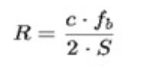

Where:

**R:** Range to the target

**c:** Speed of light

**fb :** Beat frequency (difference between transmitted and received frequencies)

**S:** Frequency modulation slope, S = (where Af is the bandwidth and T' is the sweep duration)

**3. Comparative Analysis:**

Following the individual demonstrations of Pulse and FMCW radar, a comparative analysis will be presented. This analysis focuses on how the different waveform characteristics affect the radar's ability to:

* Distinguish Targets: While Pulse Radar is effective at long-range detection with simple electronics, FMCW radar excels in applications requiring precise range and velocity measurements.
* Range Resolution: Pulse Radar provides adjustable range resolution based on pulse width, whereas FMCW radar offers finer resolution by increasing its sweep bandwidth.
* Velocity Measurement: Unlike Pulse Radar, FMCW radar is capable of measuring target velocity accurately, making it ideal for applications like automotive systems where velocity tracking is critical.

**Key Takeaways:**

Range Resolution: Understanding the trade-offs between pulse width and bandwidth for achieving better range resolution in both Pulse and FMCW radar systems.

Velocity Measurement: Demonstrating FMCW radar’s capability to measure velocity using Doppler shift, a feature absent in basic Pulse Radar systems.

Real-World Application: The demonstration concludes by discussing potential applications of each radar type. Pulse Radar’s simplicity and long-range detection make it suitable for military and air traffic control applications, whereas FMCW’s ability to track both range and velocity makes it essential for automotive radar and short-range surveillance systems.

Through this MATLAB-based project, we gain insight into how different radar waveforms influence performance metrics, showcasing the strengths and limitations of Pulse and FMCW radar in different operational contexts. This knowledge is crucial for optimizing radar systems in real-world applications.



**Software Used**

MATLAB, short for "Matrix Laboratory," is a high-level programming language and interactive environment widely used for technical computing and data visualization. Developed by MathWorks, MATLAB combines computation, visualization, and programming in a single platform, making it a powerful tool for engineers, scientists, researchers, and students across various domains.

At its core, MATLAB excels in numerical computation and matrix manipulation. It provides a rich set of built-in functions and toolboxes for solving mathematical problems, performing complex simulations, and analyzing data. MATLAB's syntax is designed to be intuitive and expressive, allowing users to write concise and readable code for a wide range of applications. One of MATLAB's key features is its interactive environment, which includes a command-line interface (CLI) and a graphical user interface (GUI). Users can execute commands, run scripts, and manipulate variables interactively in the command window, while the GUI offers tools for designing and running scripts, visualizing data, and building graphical user interfaces.

MATLAB supports a variety of data types, including scalars, vectors, matrices, arrays, and structures, making it suitable for handling diverse types of data. It also offers extensive plotting and visualization capabilities, allowing users to create 2D and 3D plots, graphs, and animations to represent and analyze their data effectively.

In addition to its core functionality, MATLAB can be extended through the use of toolboxes, which provide specialized functions and algorithms for specific applications such as signal processing, image processing, control systems, and machine learning. These toolboxes allow users to leverage MATLAB's capabilities for solving domain-specific problems efficiently.

Overall, MATLAB is a versatile and powerful platform for numerical computation, data analysis, and algorithm development, making it an indispensable tool for researchers, engineers, and students working in fields such as engineering, science, finance, and beyond. Its ease of use, flexibility, and extensive functionality make it a valuable asset for tackling a wide range of technical challenges and advancing innovation.

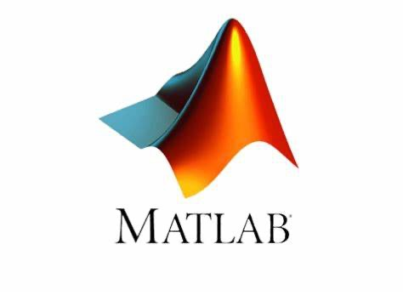

# FLOWCHART

Set Parameters for Simulation

Generate Pulse Waveform

# 0

Generate FMCW Waveform

Perform STFT for Time-Frequency Analysis (Pulse)

Perform STFT for Time-Frequency Analysis (FMCW)

Plot Spectrogram for Pulse Waveform

Plot Spectrogram for FMCW Waveform

# Algorithm

**1.Initialize Parameters:**

* Set sampling frequency (`fs`), time vector (`t`), pulse width, center frequency (`f0`), bandwidth (`bw`), and FMCW duration.

**2. Generate Pulse Waveform**:

* Create a rectangular pulse of width `pulse\_width` by setting values in `pulse\_waveform` to 1 where `t < pulse\_width`.

**3.Generate FMCW Waveform:**

* Calculate FMCW frequency slope (`fmcw\_slope = bw / fmcw\_duration`).
* For each time `t(i)`, generate the FMCW signal using the cosine function and store it in `fmcw\_waveform`.

**4. Perform Time-Frequency Analysis (STFT):**

* Use the `spectrogram` function to calculate time-frequency representations for both pulse and FMCW waveforms.

**5. Plot Waveforms:**

* Plot the time-domain pulse and FMCW waveforms.

**6. Plot Spectrograms:**

* Plot spectrograms for both the pulse and FMCW waveforms using `imagesc`.

**7. End:**

* Display all plots and conclude the analysis.

**Program**

**MATLAB CODE:**

% Radar Waveform Generation and Analysis

% Parameters

fs = 1e8; % Sampling frequency (1 MHz)

t = 0:1/fs:0.01; % Time vector for 10 ms

pulse\_width = 1e-3; % Pulse width for pulse waveform (1 ms)

f0 = 10e7; % Center frequency for FMCW (10 kHz)

bw = 2e3; % Bandwidth for FMCW (2 kHz)

fmcw\_duration = 0.01; % Duration for FMCW (10 ms)

% Generate Pulse Waveform

pulse\_waveform = zeros(size(t));

pulse\_waveform(t < pulse\_width) = 1; % Rectangular pulse

% Generate FMCW Waveform

fmcw\_waveform = zeros(size(t));

fmcw\_slope = bw / fmcw\_duration; % Frequency slope

for i = 1:length(t)

if t(i) <= fmcw\_duration

fmcw\_waveform(i) = cos(2 \* pi \* (f0 \* t(i) + (fmcw\_slope / 2) \* t(i)^2));

end

end

% Time-Frequency Analysis using Short-Time Fourier Transform (STFT)

[~, F\_pulse, T\_pulse, P\_pulse] = spectrogram(pulse\_waveform, 256, 250, 256, fs);

[~, F\_fmcw, T\_fmcw, P\_fmcw] = spectrogram(fmcw\_waveform, 256, 250, 256, fs);

% Plot Waveforms

figure;

subplot(3, 1, 1);

plot(t, pulse\_waveform);

title('Pulse Waveform');

xlabel('Time (s)');

ylabel('Amplitude');

subplot(3, 1, 2);

plot(t, fmcw\_waveform);

title('FMCW Waveform');

xlabel('Time (s)');

ylabel('Amplitude');

% Plot Spectrograms

subplot(3, 1, 3);

imagesc(T\_pulse, F\_pulse, 10\*log10(abs(P\_pulse)));

axis xy;

title('Spectrogram of Pulse Waveform');

xlabel('Time (s)');

ylabel('Frequency (Hz)');

colorbar;

figure;

imagesc(T\_fmcw, F\_fmcw, 10\*log10(abs(P\_fmcw)));

axis xy;

title('Spectrogram of FMCW Waveform');

xlabel('Time (s)');

ylabel('Frequency (Hz)');

colorbar;

**RESULTS:**

**CASE:1**

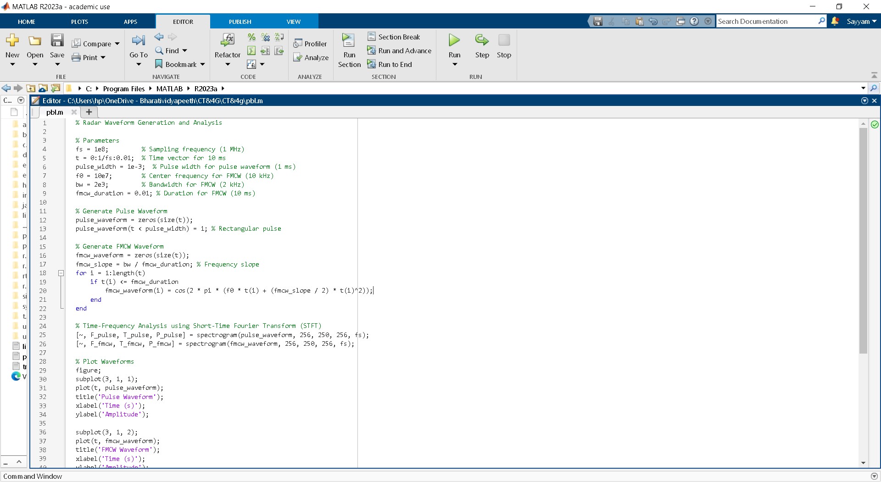

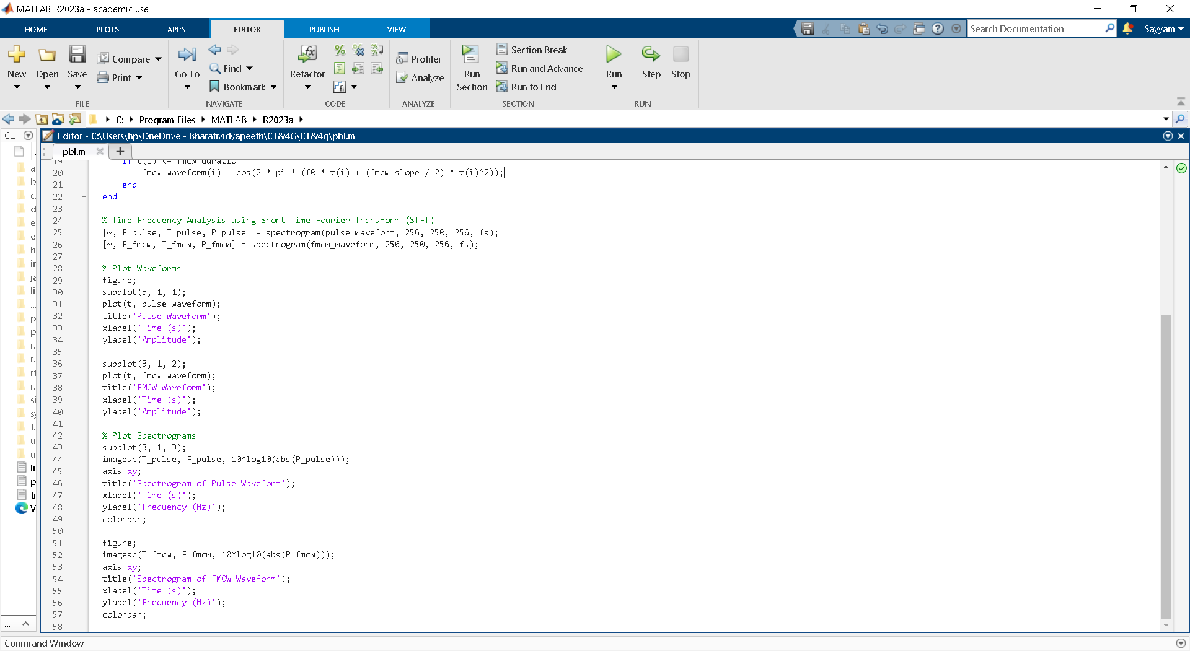

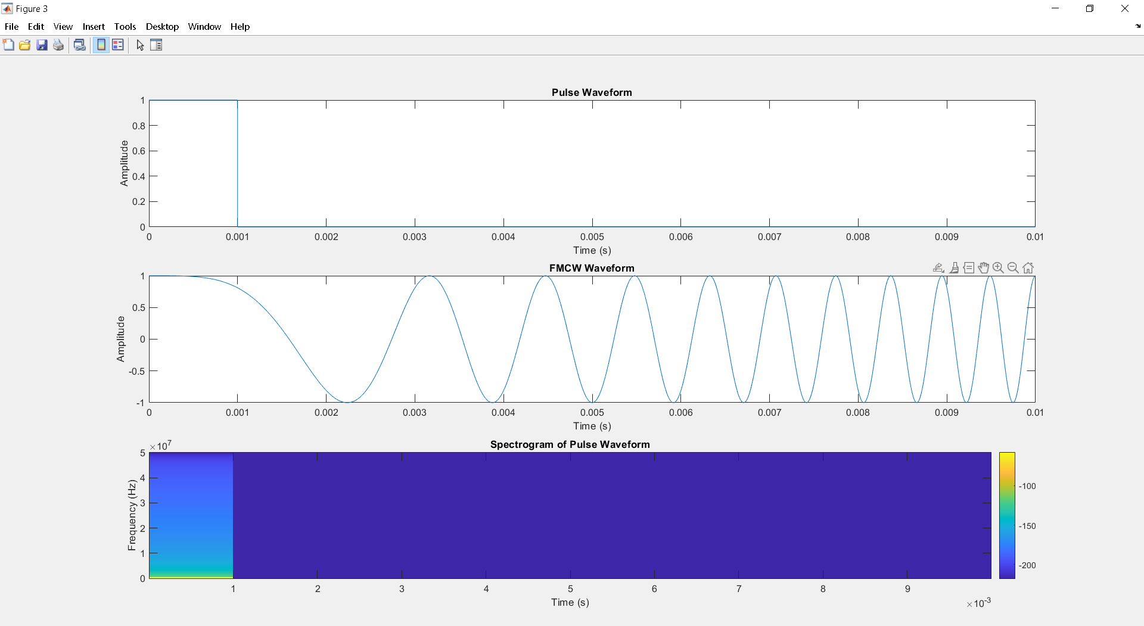

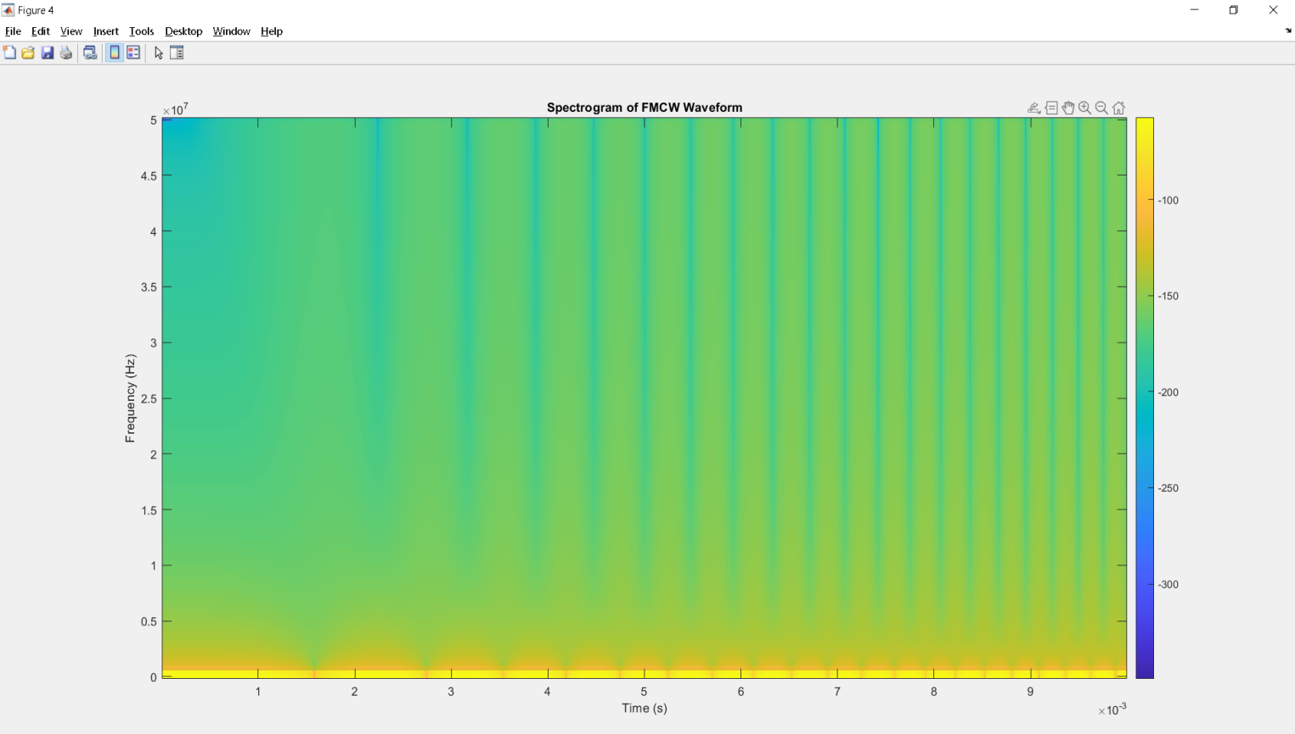

**CASE:2**

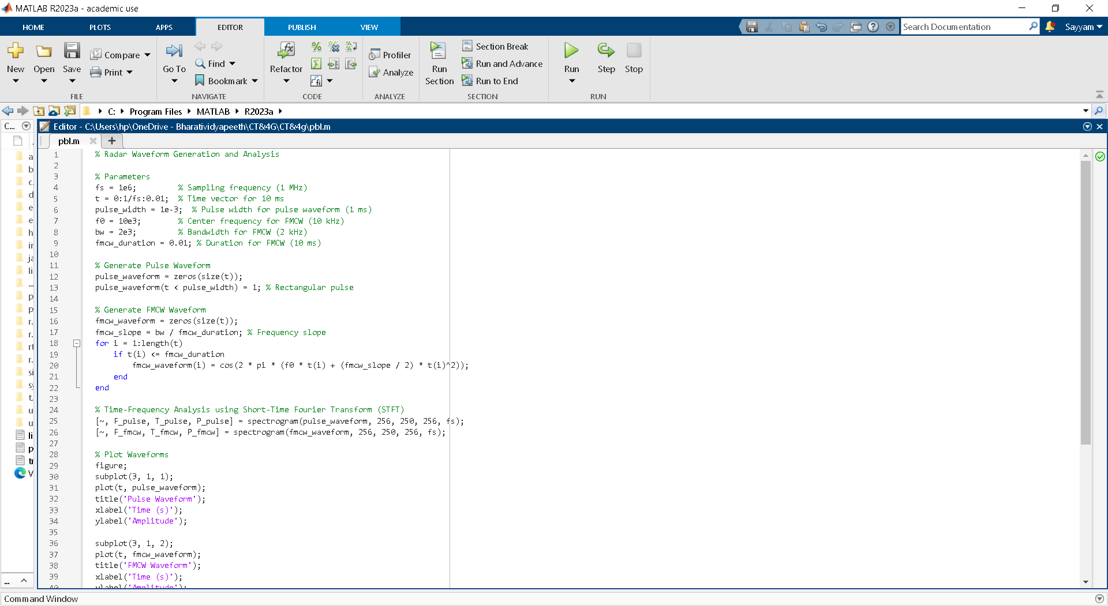

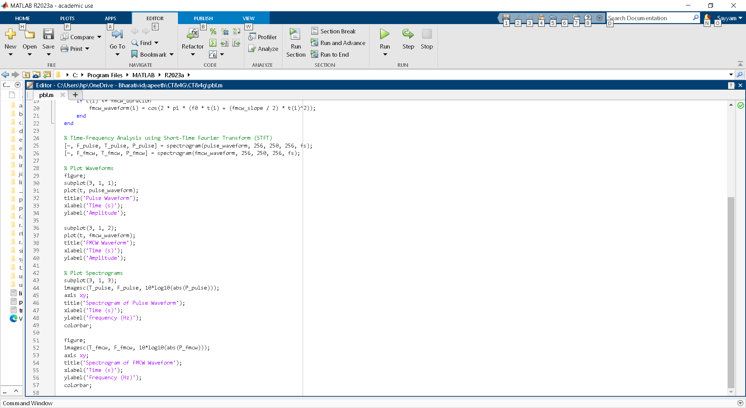

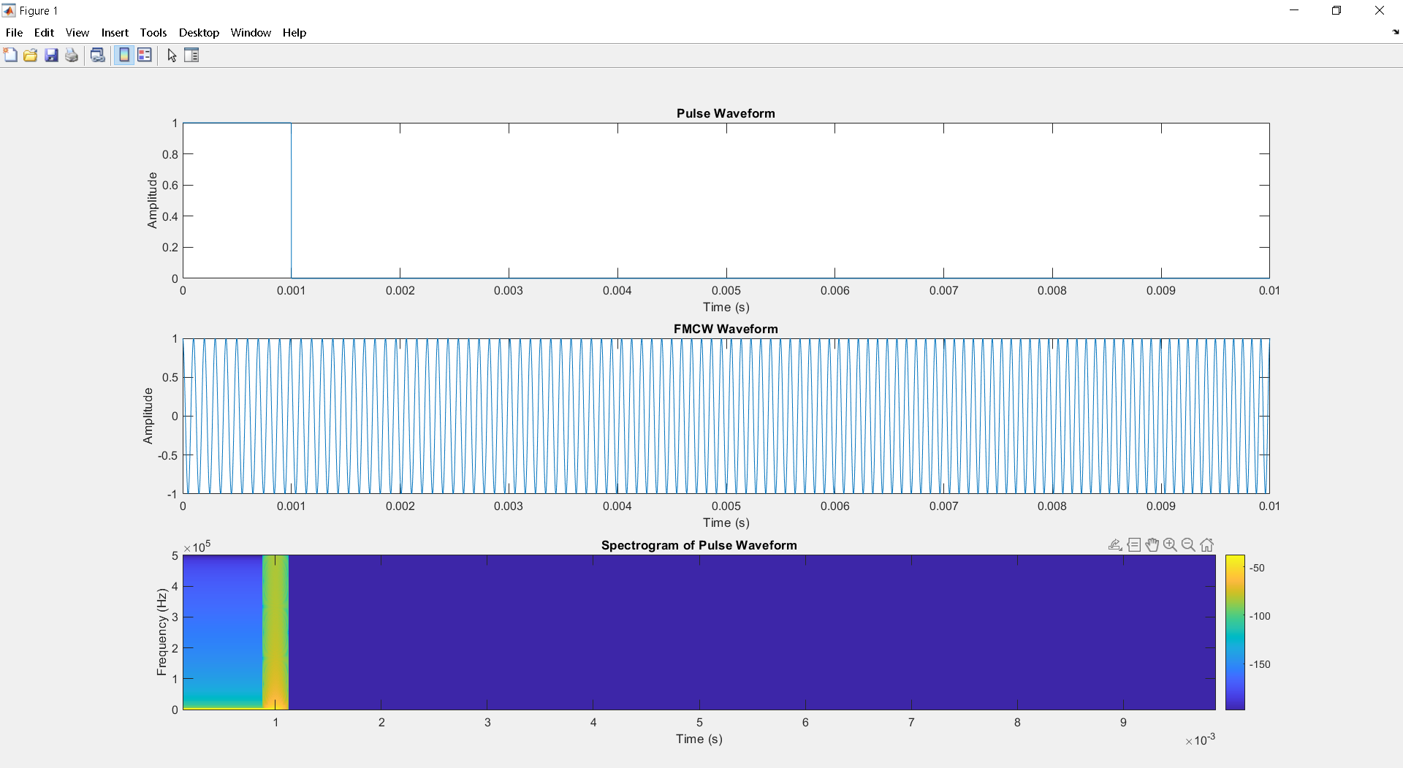

# C:\Users\admin\AppData\Local\Packages\5319275A.WhatsAppDesktop_cv1g1gvanyjgm\TempState\DB771BF001F388486298A2FCD68C2DFB\Figure 2 02-10-2024 17_23_36.png

# COURSE OUTCOME

* **CO5:** Interpret the working of the radar
* **CO6**: Analyse the performance using the Radar Equations

Hence CO1 & CO2 has been satisfied.

# CONCLUSION

This project successfully demonstrated the generation and analysis of different radar waveforms, specifically pulse and FMCW. By analyzing the radar performance based on key parameters such as range, velocity resolution, and SNR, it was concluded that the choice of radar waveform depends on the specific application requirements.The project has also evaluated the impact of these waveforms on radar performance, including range resolution, Doppler resolution, and SNR.

The results of the project have shown that:

* Pulse waveforms are suitable for applications that require high range resolution and low Doppler resolution.
* FMCW waveforms are suitable for applications that require high Doppler resolution and low range resolution.
* The choice of radar waveform can significantly impact the performance of the radar system, and the selection of the waveform should be based on the specific requirements of the application.

The study of radar waveform generation opens pathways for further research into advanced techniques like MIMO (Multiple-Input Multiple-Output) radar, synthetic aperture radar (SAR), and cognitive radar systems.

**References**

# [bing.com/ck/a?!&&p=9f3e8c36f6e09f37a60b75b21d42d96a7cfde39dd4fbbbb9eebd0c8a7c6585cfJmltdHM9MTcyNzQ4MTYwMA&ptn=3&ver=2&hsh=4&fclid=26c81003-1d23-6f23-1889-021c1cd16e54&psq=Generate+and+analyze+different+radar+waveforms+(e.g.%2c+pulse%2c+FMCW)+and+their+impact+on+radar+performance.&u=a1aHR0cHM6Ly93d3cubWF0aHdvcmtzLmNvbS9oZWxwL3JhZGFyL3VnL2dlbmVyYXRlLW5vdmVsLXJhZGFyLXdhdmVmb3Jtcy11c2luZy1HQU4uaHRtbA&ntb=1](https://www.bing.com/search?pglt=43&q=Generate+and+analyze+different+radar+waveforms+(e.g.%2C+pulse%2C+FMCW)+and+their+impact+on+radar+performance.&cvid=ad840f64146548e19d405f8cf9fee970&gs_lcrp=EgZjaHJvbWUyBggAEEUYOTIGCAEQRRg7MgYIAhBFGD3SAQc0MTZqMGoxqAIAsAIA&FORM=ANNTA1&PC=U531)

* [**FMCW Radar - Principles, Characteristics, Block Diagram, Applications (geeksforgeeks.org)**](https://www.geeksforgeeks.org/fmcwr-radar/)

**GETHUB =**